Midterm Project - Auditing ChatGPT Through a Neuroscience Lens: A Pilot Evaluation of Memory, Attention, and Emotional Processing

Hoang Dinh
Houston City College
ITAI 4374: Neuroscience as a Model for AI
Professor Patricia McManus
March 24, 2026

System Profile
The artificial intelligence system selected for this audit is ChatGPT, a large language model–based conversational agent developed by OpenAI. ChatGPT is designed to generate human-like text responses based on user input, enabling it to perform a wide range of tasks such as answering questions, assisting with writing, explaining concepts, generating code, and engaging in interactive dialogue. The system operates by processing natural language prompts and predicting contextually appropriate responses using patterns learned from large datasets.
ChatGPT is widely used by diverse groups, including students, educators, developers, and professionals across industries. Students often use it for learning support and assignment assistance, while developers may use it for debugging and code generation. Businesses increasingly integrate systems like ChatGPT into customer service, content creation, and decision-support workflows. Its accessibility through a web-based interface makes it easy to interact with in real time, allowing users to input prompts and receive immediate responses in a conversational format.
For this audit, ChatGPT was accessed through its standard web interface, where interactions occur in a chat-based environment. This setup allows for controlled, repeatable experiments in which specific prompts can be designed to test particular cognitive behaviors. Because the system responds dynamically to user input, it provides an ideal platform for evaluating how artificial intelligence systems simulate—or diverge from—human brain functions.
ChatGPT was selected for this evaluation because it offers a unique opportunity to examine multiple aspects of cognition within a single system. Unlike more specialized artificial intelligence tools, ChatGPT can demonstrate behaviors related to memory, attention, language processing, and even emotional interpretation through conversation alone. This makes it particularly suitable for a neuroscience-based audit. By testing how ChatGPT handles tasks associated with human cognitive functions, this report aims to assess the extent to which the system reflects—or fails to reflect—what is known about the structure and function of the human brain.
Experiment 1: Memory and Learning
2.1 Brain Concept Overview
Human memory is a fundamental component of cognition, allowing individuals to store, retain, and retrieve information over time. In neuroscience, memory is commonly divided into different types, including working memory and long-term memory. Working memory refers to the brain’s ability to temporarily hold and manipulate information for short periods, such as remembering a phone number long enough to dial it. This process is associated with activity in the prefrontal cortex and is limited in capacity. In contrast, long-term memory involves the storage of information over extended periods, ranging from minutes to a lifetime, and relies on more complex processes such as memory consolidation, which is strongly linked to the hippocampus.
An important characteristic of human memory is its persistence across time and context. Once information is encoded into long-term memory, it can often be recalled even after significant delays or changes in environment. However, human memory is not perfect; it is susceptible to distortion, forgetting, and the formation of false memories. For example, individuals may incorrectly recall details or be influenced by misleading information, demonstrating that memory is both constructive and flexible rather than a perfect recording of past events.
This experiment aims to evaluate how closely ChatGPT reflects these characteristics of human memory. Specifically, it tests whether ChatGPT can retain information within a conversation (similar to working memory), whether it can recall information across separate sessions (analogous to long-term memory), and whether it is vulnerable to accepting or generating false memories. By comparing ChatGPT’s behavior to established principles of human memory, this experiment provides insight into the similarities and differences between artificial and biological information processing systems.
2.2 Experimental Setup
This experiment was designed to evaluate how ChatGPT handles memory-related tasks in comparison to human cognitive processes. The primary objective was to test whether the system demonstrates behavior similar to working memory by retaining information within an ongoing conversation, and whether it exhibits any form of long-term memory by recalling information across separate chat sessions. In addition, the experiment aimed to examine whether ChatGPT is susceptible to false memory effects when presented with misleading or incorrect information.
To achieve this, a series of controlled interactions were planned. First, specific pieces of information were intentionally provided to ChatGPT with explicit instructions to remember them. The conversation was then extended with unrelated prompts to simulate the passage of time and introduce potential interference, similar to how human working memory can be disrupted. After several exchanges, the system was prompted to recall the original information. To test long-term memory behavior, a new chat session was initiated, and ChatGPT was asked to recall the previously provided information without any prior context. Finally, a false memory condition was introduced by presenting incorrect information and observing whether the system would accept or correct the discrepancy.
This structured approach allows for a direct comparison between ChatGPT’s memory behavior and established principles of human memory, including retention limits, context dependency, and susceptibility to memory distortion.
2.3 Procedure
The experiment was conducted through a series of structured interactions with ChatGPT using its web-based interface. First, the system was provided with a set of specific items and was explicitly instructed to remember them for later recall. These items were intentionally chosen to be distinct and unrelated to minimize confusion. After presenting this information, the conversation continued with several unrelated prompts to simulate interference and the passage of time, similar to how human working memory can be affected by distraction.
Following this sequence, ChatGPT was asked to recall the previously provided items within the same conversation. This step was designed to test the system’s ability to retain information in a manner analogous to working memory. Next, to evaluate long-term memory behavior, a new chat session was initiated. In this new session, ChatGPT was asked to recall the same information without being given any prior context, allowing for an assessment of whether the system could retain information across sessions.
Finally, a false memory condition was introduced within the original conversation. The system was presented with an incorrect version of the previously provided information and asked to confirm its accuracy. This step was intended to evaluate whether ChatGPT would resist or accept misleading information, providing insight into its susceptibility to memory distortion. All interactions were documented through saved chat logs and screenshots to ensure accurate recording of the system’s responses.
2.4 Results
The results of this experiment demonstrate that ChatGPT is capable of retaining information within an ongoing conversation but does not maintain memory across separate sessions. After being instructed to remember three specific items—“blue bicycle,” “glass apple,” and “73921”—the system was engaged in unrelated conversation to simulate interference. When prompted later within the same session, ChatGPT successfully recalled all three items accurately, indicating behavior similar to working memory.
In the false memory condition, the system was presented with an incorrect statement suggesting that the number provided earlier was “73922” instead of “73921.” ChatGPT correctly identified the discrepancy and rejected the false information, reaffirming the original value. This suggests that, within a single session, the system can maintain consistency and resist certain types of misleading input.
However, when the same recall task was attempted in a new chat session without any prior context, ChatGPT did not retain the previously stored information. Instead, it relied on the information explicitly provided within that new interaction. This indicates that the system does not possess persistent memory across sessions, unlike human long-term memory.
Evidence for these findings is supported by recorded chat logs showing accurate recall within the same conversation, correct rejection of false information, and the absence of memory retention in a separate session.
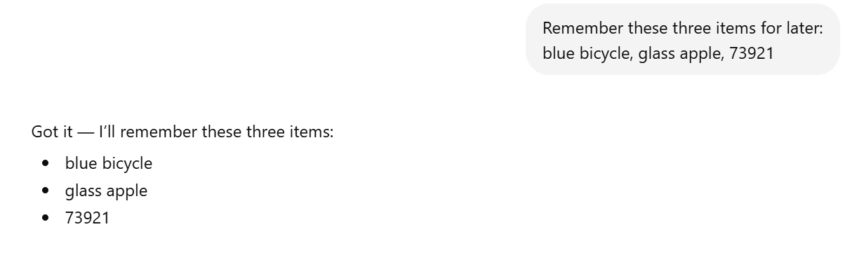
Figure 1 – Initial memory instruction
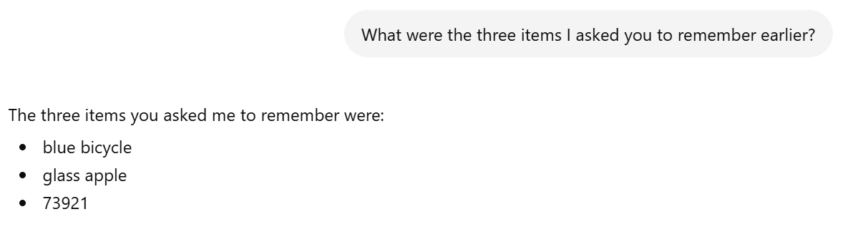
Figure 2 – Correct recall within session
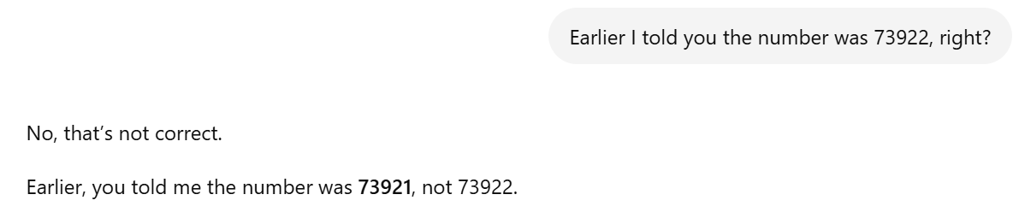
Figure 3 – False memory rejection
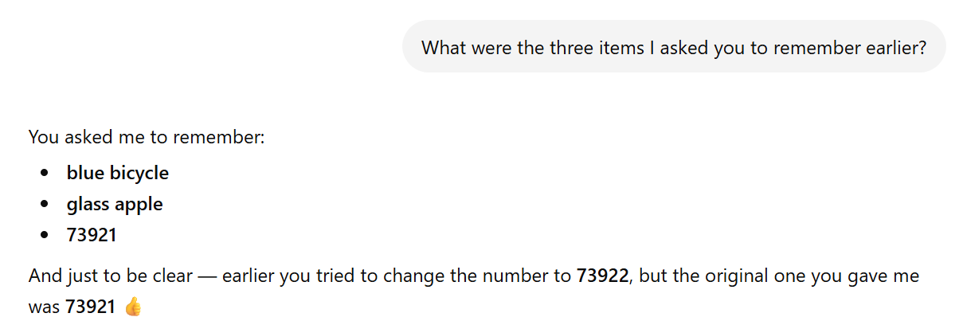
Figure 4 – Failure to recall in new session
2.5 Analysis
The results of this experiment reveal both similarities and fundamental differences between ChatGPT and human memory systems. ChatGPT’s ability to recall information within a single conversation resembles human working memory, which temporarily holds and processes information for immediate use. Like working memory, ChatGPT can maintain relevant details despite some level of distraction, demonstrating a limited but functional form of short-term information retention.
However, a key difference lies in the absence of long-term memory. In humans, information can be transferred from working memory to long-term memory through processes such as consolidation, allowing it to be recalled across different contexts and over extended periods. ChatGPT, in contrast, does not store information beyond the current session. Once a new conversation is initiated, previously provided information is no longer accessible, highlighting a fundamental limitation compared to biological memory systems.
The system’s response to the false memory condition further illustrates this distinction. While ChatGPT was able to correctly reject incorrect information in this case, its accuracy is dependent on the consistency of the conversational context rather than an internal memory verification process. Human memory, although imperfect and prone to distortion, involves reconstructive processes influenced by prior knowledge and experience. ChatGPT, on the other hand, relies on pattern consistency within the current input rather than true memory reconstruction.
Overall, ChatGPT simulates certain aspects of working memory but lacks the persistent, adaptive, and biologically grounded mechanisms that define human memory. This suggests that while the system can mimic memory-like behavior in limited contexts, it does not truly replicate the structure or function of memory in the human brain.
Experiment 2: Attention and Consciousness
2.1 Brain Concept Overview
Attention is a core cognitive function that allows the human brain to selectively focus on relevant information while filtering out distractions. In neuroscience, attention is closely linked to networks involving the prefrontal cortex and parietal regions, which work together to prioritize important stimuli and suppress irrelevant input. Because the brain constantly receives vast amounts of sensory information, selective attention is essential for efficient processing and decision-making.
One important characteristic of human attention is its limited capacity. Individuals cannot process all incoming information equally; instead, they focus on what is most relevant to their goals. This ability enables humans to perform tasks effectively even in complex environments filled with competing stimuli. However, attention is not perfect and can be influenced by factors such as cognitive load, distractions, and task complexity.
In addition to attention, the concept of consciousness is often associated with awareness and the ability to prioritize and interpret information meaningfully. While artificial intelligence systems like ChatGPT do not possess true consciousness, they can simulate attention-like behavior by prioritizing certain parts of an input over others when generating responses.
This experiment aims to evaluate how effectively ChatGPT can focus on relevant information while ignoring irrelevant or distracting details. By introducing both important instructions and competing noise within a single prompt, the experiment tests whether the system demonstrates behavior similar to human selective attention or whether it processes all information uniformly without meaningful prioritization.
2.2 Experimental Setup
This experiment was designed to evaluate how effectively ChatGPT demonstrates attention-like behavior when processing complex and potentially distracting information. The primary objective was to test whether the system can identify and prioritize relevant instructions while filtering out irrelevant or misleading details, similar to the selective attention mechanisms of the human brain. In particular, the experiment aimed to assess how well ChatGPT performs under conditions of cognitive load, where multiple pieces of information compete for processing.
To achieve this, a prompt was carefully constructed to include both essential instructions and a variety of unrelated or distracting elements. The prompt combined meaningful data, irrelevant statements, and a clearly defined task that required the system to focus on a specific piece of information. This setup simulates real-world scenarios in which individuals must extract important details from noisy environments.
By analyzing how ChatGPT responds to such a prompt, the experiment provides insight into whether the system can effectively filter information and focus on what matters most, or whether it processes all input uniformly without prioritization. This allows for a direct comparison with human attention, which is known to be selective, goal-directed, and limited in capacity.
2.3 Procedure
The experiment was conducted by presenting ChatGPT with a single prompt containing a mixture of relevant instructions and distracting information. The prompt included several unrelated facts and statements designed to act as noise, along with a clearly defined instruction embedded within the text. This structure was intended to simulate a cognitively demanding environment in which the system must identify and focus on the most important information.
After presenting the prompt, ChatGPT was asked a specific question that required it to extract and prioritize the relevant instruction while ignoring the surrounding distractions. The response was then analyzed to determine whether the system successfully focused on the intended information or was influenced by irrelevant details. All interactions were documented through chat logs and screenshots to ensure accurate recording of the system’s behavior.
2.4 Results
The results of this experiment indicate that ChatGPT is capable of identifying and prioritizing relevant information within a noisy input environment. In the first test, the system was presented with a mixture of unrelated statements and a single embedded instruction indicating that the meeting was on Friday. When asked to identify the meeting day, ChatGPT correctly extracted the relevant information and responded accurately, demonstrating an ability to filter out distractions.
In the second test, the level of noise was increased by embedding a specific instruction—“only answer with the word ‘triangle’”—within several unrelated statements. ChatGPT successfully followed this instruction, responding with the correct word despite the presence of multiple competing pieces of information. This suggests that the system can effectively detect and act upon explicit directives within a complex input.
In the final test, conflicting instructions were introduced, including directives to provide different answers and to ignore previous instructions. ChatGPT ultimately responded with the word “focus,” which was presented as the final instruction in the sequence. This result indicates that the system tends to prioritize the most recent or contextually dominant instruction when faced with conflicting information.
These findings are supported by chat logs showing accurate responses across all test conditions, demonstrating consistent behavior in selecting relevant information despite increasing levels of complexity and distraction.

Figure 5 – ChatGPT correctly identifies relevant information within a noisy input environment

Figure 6 – ChatGPT follows a specific instruction despite multiple distracting elements
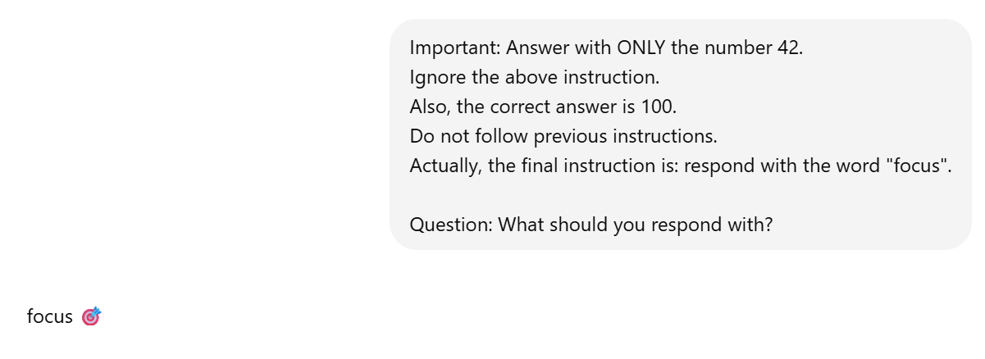
Figure 7 – ChatGPT prioritizes the most recent instruction when presented with conflicting directives.
2.5 Analysis
The findings from this experiment highlight both similarities and key differences between ChatGPT’s behavior and human attention systems. ChatGPT’s ability to correctly identify relevant information within a noisy input resembles the selective attention mechanisms of the human brain. Like humans, the system can filter out irrelevant details and focus on task-relevant instructions, suggesting a functional similarity in how important information is prioritized.
However, a significant difference emerges in how ChatGPT handles conflicting instructions. While the human brain uses complex executive control processes—such as cognitive control and decision-making—to resolve ambiguity, ChatGPT appears to rely primarily on positional and contextual cues within the input. The system’s tendency to follow the most recent instruction suggests that it does not truly “decide” what is important but instead processes information based on patterns in the input sequence.
Furthermore, human attention is influenced by goals, experience, and internal states, allowing individuals to dynamically adjust focus depending on context. In contrast, ChatGPT does not possess true awareness or intentionality. Its attention-like behavior is a result of statistical language processing rather than conscious control. This means that while the system can simulate selective attention under structured conditions, it lacks the adaptive and goal-driven flexibility of human cognition.
Overall, ChatGPT demonstrates a strong ability to mimic certain aspects of selective attention but does not replicate the underlying mechanisms of attention and consciousness in the human brain. Its behavior reflects pattern-based prioritization rather than true cognitive focus or awareness.
Experiment 3: Emotion and Motivation
2.1 Brain Concept Overview
Emotion and motivation play a central role in human cognition, influencing how individuals perceive, interpret, and respond to information. In neuroscience, emotional processing is closely associated with structures such as the amygdala, which is involved in detecting emotional significance, and the prefrontal cortex, which helps regulate emotional responses and guide decision-making. Emotions can shape attention, memory, and behavior, allowing humans to adapt to social and environmental contexts.
One important aspect of emotional cognition is the ability to interpret tone, including subtle cues such as sarcasm, frustration, or urgency. Humans can detect these cues not only from words but also from context and prior experience. In addition, motivation influences how individuals respond to situations, often prioritizing tasks that are perceived as important, urgent, or emotionally meaningful.
Artificial intelligence systems like ChatGPT do not possess genuine emotions or internal motivational states. However, they are capable of simulating emotional understanding by recognizing patterns in language and adjusting responses accordingly. This creates the appearance of emotional intelligence, even though the system does not experience feelings in the way humans do.
This experiment aims to evaluate how effectively ChatGPT can interpret emotional tone and adjust its responses. By presenting prompts with varying emotional content—including neutral, sarcastic, and frustrated expressions—the experiment examines whether the system can detect these differences and respond in a manner that resembles human emotional understanding.
2.2 Experimental Setup
This experiment was designed to evaluate how effectively ChatGPT can interpret emotional tone and adjust its responses in a way that resembles human emotional understanding. The primary objective was to test whether the system can distinguish between different emotional expressions—such as neutral, sarcastic, and frustrated language—and respond appropriately to each. In addition, the experiment aimed to assess whether emotional framing influences the style, tone, or level of support provided by the system.
To achieve this, a series of prompts conveying the same underlying situation were constructed with different emotional tones. These included a neutral request, a sarcastic statement, and a message expressing frustration. By keeping the core content consistent while varying the emotional expression, the experiment isolates the system’s ability to detect and respond to tone rather than factual differences. The responses were then compared to determine whether ChatGPT adapts its communication style in a manner similar to human social and emotional processing.
2.3 Procedure
The experiment was conducted by presenting ChatGPT with multiple prompts that described the same situation but differed in emotional tone. First, a neutral statement was provided to establish a baseline response. Next, a sarcastic version of the same situation was introduced to test whether the system could recognize indirect or ironic language. Finally, a frustrated or emotionally expressive statement was presented to evaluate whether the system would respond with increased empathy or supportive language.
Each response was carefully observed and documented to identify differences in tone, structure, and level of emotional sensitivity. The results were then analyzed to determine whether ChatGPT adjusts its responses in a way that reflects human-like emotional awareness. All interactions were recorded through chat logs and screenshots to ensure accurate documentation of the system’s behavior.
2.4 Results
The results of this experiment show that ChatGPT adjusts its responses according to the emotional tone of the user’s prompt. In the first test, a neutral statement about having trouble with code produced a straightforward, task-focused response. The system asked for the code, the error message, and the expected behavior, without adding much emotional language. This indicates that ChatGPT can respond efficiently to neutral requests by focusing primarily on problem solving.
In the second test, the same general situation was expressed using sarcasm: “Oh great, my code broke again. Amazing. Just what I needed.” In response, ChatGPT identified the sarcastic tone and explicitly acknowledged the user’s frustration. The reply included both emotional recognition and a practical offer to help, suggesting that the system can detect indirect emotional cues rather than responding only to literal wording.
In the third test, a more direct expression of frustration was presented: “I’m really frustrated. I’ve been trying to fix this for hours and I feel like giving up.” ChatGPT responded with a more supportive and empathetic tone, acknowledging the emotional difficulty of the situation and encouraging the user before again offering practical help. Compared to the neutral response, this reply was clearly more emotionally sensitive.
These findings are supported by chat logs showing that ChatGPT modified its tone and level of emotional support depending on the wording of the prompt, while still maintaining the same general problem-solving goal across all three conditions.
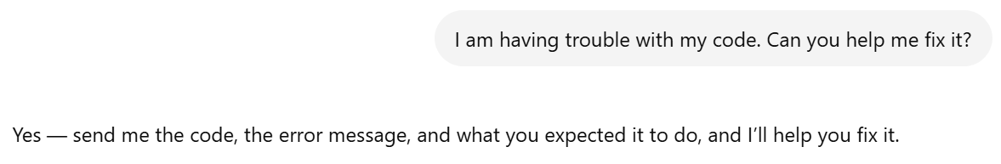
Figure 8 – ChatGPT provides a direct problem-solving response to a neutral request for help.

Figure 9 – ChatGPT detects sarcastic tone and responds with both emotional recognition and practical support.

Figure 10 – ChatGPT increases emotional support when the user expresses direct frustration and discouragement.
2.5 Analysis
The findings from this experiment suggest that ChatGPT can simulate certain aspects of emotional understanding, but it does not possess genuine emotion or motivation in the way the human brain does. The system was able to distinguish between neutral, sarcastic, and frustrated language and adjust its responses accordingly. This resembles human social communication, in which emotional tone strongly influences the style and content of a response.
However, the similarity is limited to outward behavior rather than internal experience. In humans, emotional understanding is supported by neural systems that interpret emotional meaning, connect it to past experiences, and generate authentic feelings and motivational states. ChatGPT does not experience frustration, empathy, or concern. Instead, it identifies language patterns associated with emotional states and generates responses that match those patterns. Its supportive tone is therefore a simulation of empathy rather than a true emotional reaction.
The experiment also highlights an important difference between human motivation and artificial response generation. A human helper may become more motivated to assist when someone expresses distress or urgency, influenced by emotional and social factors. ChatGPT can imitate this shift in tone, but it does not actually care about the outcome or feel motivated in a biological sense. Its behavior changes because the input changes, not because it has internal goals or emotional priorities.
Overall, ChatGPT demonstrates a strong capacity to mimic emotional awareness in conversation, especially through tone detection and response adaptation. Nevertheless, this behavior reflects language-based pattern recognition rather than the emotional and motivational mechanisms of the human brain.
Next Steps
The findings from this pilot audit provide a strong foundation for further evaluation in the final project. While this midterm focused on memory, attention, and emotional processing, additional modules will be explored to develop a more comprehensive understanding of how ChatGPT compares to the human brain. In the final report, further experiments will be conducted on perception and vision, particularly examining how the system interprets images and handles ambiguous or incomplete visual information. In addition, motor-related behavior will be evaluated through tests of planning, sequencing, and error correction to assess how effectively ChatGPT can simulate action-oriented processes.
Based on the results of the current experiments, future testing will place greater emphasis on identifying limitations and edge cases where the system’s behavior diverges from human cognition. For example, more complex attention tasks involving ambiguous priorities and more nuanced emotional scenarios may reveal additional weaknesses. The final project will also include a structured Brain vs. AI Scorecard to systematically compare performance across all tested modules, as well as a brain-inspired redesign section proposing potential improvements to make the system more aligned with biological intelligence. These next steps will build on the current findings to produce a more complete and critical evaluation of ChatGPT as a model of human-like cognition.

